# RLA concept

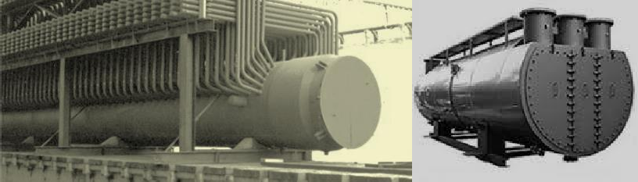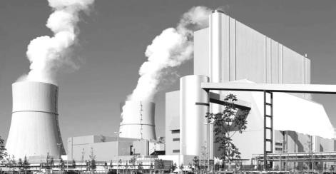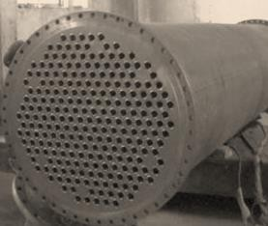

**Remaining Life Assessment (RLA) Services**

**ABHISHEK TECHNICAL SERVICES** undertakes comprehensive RLA studies of boilers in India and abroad. High end metallurgical expertise and a unique understanding of damage mechanisms provide us a distinct acceptance to end users.

Due to continuous use under high pressure and temperature, material properties degrade and effective life is consumed. The major degradation process is creep of the material which occurs under high temperature and pressure. Based on code and standards, the power plants and boilers are designed for 15- 30 years of the creep life. Thermal and creep degradation of material reflects in microstructure; hence it is useful to estimate Remaining life. The other degradation mechanisms are fatigue and delayed cracking of the weld due to fabrication related defects as they open up after several years of service.

Creep is an irreversible damage. An onset of creep if it is in final stage the component needs to be retired from the plant otherwise it can lead to catastrophic failure. However, in case of localized damages like cracking in the weld or flange or bend which can be replaced or repaired depending upon the nature of the problem. In case of any localized problem is observed, it can be rectified and overall integrity of the system can be improved.

RLA defines the inspection period and maximum life before the next inspection. It can be predicted up to 5 years. RLA studies give great benefit to operating plants as they can plan their inventory and components spares as well as suggestion on operation which can prevent damages. By adopting this philosophy, advanced countries have extracted the life of a power plant or process plant from 1.5 to 2 times then the original design life.

**ATS** has competent and trained manpower to perform these testing and assessment in the shortest duration possible to reduce the downtime of the plants to meet the stringent production targets. **ATS** is approved “**well known remnant life assessment organization”** recognized by Central Boilers Board (CBB), Government of India, Ministry of commerce and industries.

# Need for RLA of Boilers

Increasing cost of new equipment and diminishing resources

Extended lead time in plant construction

Stringent environmental, safety and other regulations Increasing awareness of the technological feasibility of extending component life

# Reasons for Remaining Life Estimation Study

The high temperature operations of pressure parts are subjected to creep stress at elevated pressure.

The starting and stopping of the Boiler Unit results in fatigue stress

The fuels burnt can cause corrosion in various areas in the boiler

The water used for steam generation leaves deposits inside the tube which increases the metal temperature leading to long term overheating.

Residual stresses during manufacturing, the vibrations due to flow over the tube, mechanical vibrations, erosion due to the abrasive nature of the fuel etc. do occur in a boiler.

When a boiler is operated beyond the specified operating parameters.

All of the above, individually or combined, lead to material degradations of different magnitude and will lead to a failure unless RLA is not carried out.

# Potential degradation expected in boiler components.

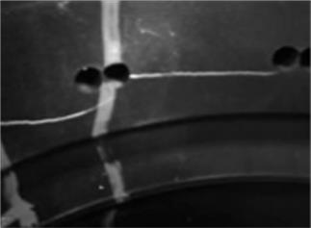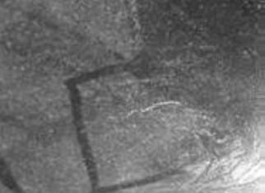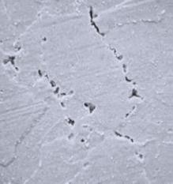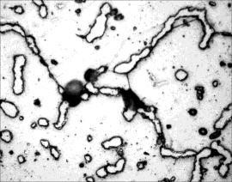

Potential degradation of various boiler components are summarized in following table

|  |  |  |  |  |  |
| --- | --- | --- | --- | --- | --- |
|  | Creep | Thermal Fatigue | Embrittlement | Erosion | Corrosion |
| Evaporator |  | X | H² | X | X |
| Drum | x | X |  |  | X |
| Superheater | X |  |  |  | X |
| Reheater tubes | X |  |  |  | X |
| Superheater header | X | X |  |  | X |
| Reheater headers | X | X |  |  | X |
| Desuperheater nozzles | X | X |  | X | X |
| Steam lines | X | X |  |  | X |
| Feedwater lines |  |  |  | X | X |

# RLA Methodology

ATS has approach towards Life assessment Collecting boiler Past record, History, Original Data, Original Drawing of boiler Analytic considerations, calculation methods, the relevant non-destructive tests, correct selection of Boiler components is important for the RLA study ATS follows “3 Stage” RLA Methodology approach.

Stage 1: Collection of Design Data & operation history.

Stage 2: Review of operating, maintenance and inspection history.

Stage 3: Scientific Approach based on Stage 1 & 2 data in combination with quantified material properties.

# RLA Study Approach

RLA study is undertaken by ATS with following approach. Collection of background data and history of Boiler Operation.

Understanding the actual degradation mechanism Fatigue, Thermal Fatigue, Thermo Mechanical Fatigue Thermal Aging

Creep Embitterment Corrosion

Thorough visual examination by an expert

Dimensional measurement at critical locations. Collection of scale and deposits samples for analysis. Thickness Survey.

Internal oxide scale measurement at superheater tube and Re-heater tube.

WFMPI of main weld joints of Header and Steam Drum.

In-Situ metallography to determine thermal ageing and creep related problem from a RLA perspective.

In-Situ hardness measurement with portable hardness tester.

Suggestions on repairing.

If required, repairing of the equipment is suggested, for life extension.

Calculation and judgment of remaining life based on analysis.

# Facilities available for carrying RLA

ATS also have state of the art testing equipment required for carrying out non-destructive testing at site doe RLA study.

Eddy current tester PMI machine

Internal Oxide thickness Gauge Ultrasonic Flaw Detector

In-situ Metallography Kit

Electro Magnetic Crack Detector (Yoke Type) Ultra Violet Black Light for WFMPI and FDP Acoustic Eye™, Dolphin G3 system

Dye Penetration Kit Ultrasonic Thickness Gauge

High temperature probe for thickness measurement.

Coil type MPI Machine

UCI/ Rebound type Portable Hardness tester Baroscopic examination Kit.



*company of TCR Engineering P. Ltd.* ***o m***